Douane e-Commerce (DECO)

Section 6 – Message Flows

Message Implementation Guidelines

MIG document version: 2.00

Copyright © 2022 Dutch Customs

Table of content
1 DECO message flows 3
1.1 Processing of the IE415 with “additional declaration type” “D” (pre-lodged standard declaration) 3
1.2 Processing of IE432 Presentation notification (PN) 6
1.3 Handling after control 10
1.4 Processing of IE414 Invalidation request 20

DECO message flows

Processing of the IE415 with “additional declaration type” “D” (pre-lodged standard declaration)

Rejection of the IE415 Declaration type “D” in the “Portal” with a XMLCNT XML control message (Rejection due to technical error(s)) or rejection of the IE415 Declaration type “D” with an IE456 Rejection functional message from the DECO system.
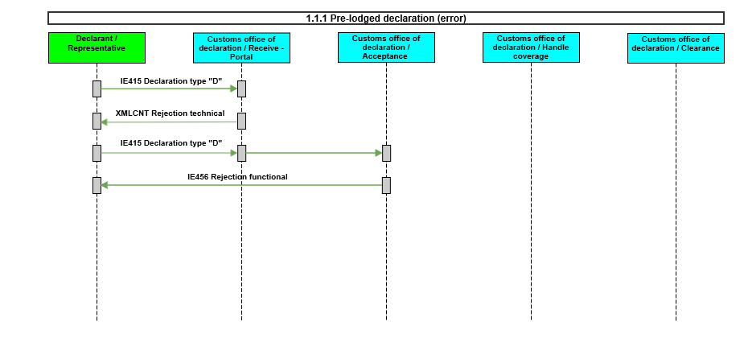

Acceptance of the IE415 Declaration type “D” and registration of the pre-lodged declaration with the IE426 Registration notification in case of no control.
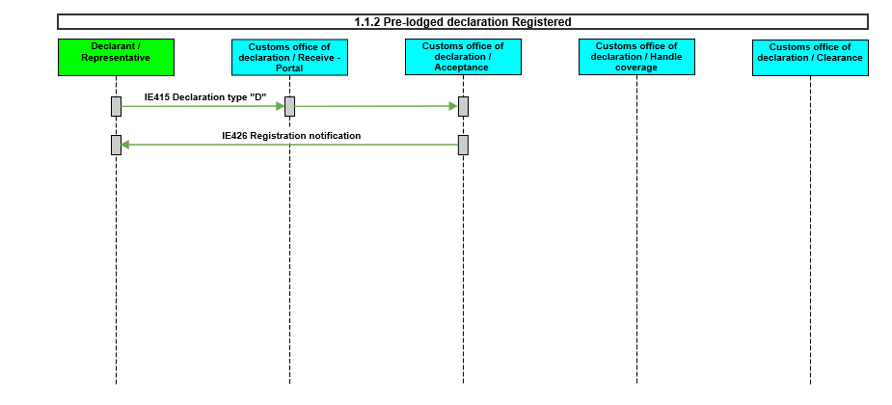

Acceptance of the IE415 Declaration type “D” and registration of the pre-lodged declaration with the IE426 Registration notification and an IE460 Control notification.
Note: the control notification is sent at this moment only in case the declarant has an AEOC authorisation.
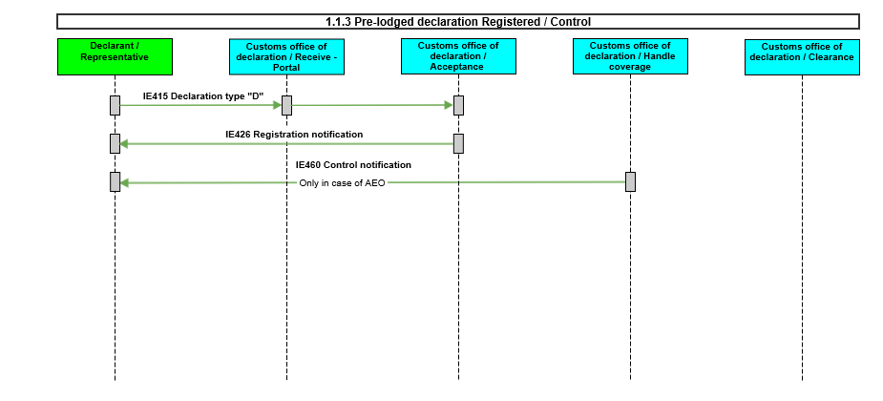

Acceptance of the IE415 Declaration type “D” and registration of the pre-lodged declaration with the IE426 Registration notification in case of no control.
No IE432 Presentation notification is received within the 30 days period.
Rejection of the IE415 Declaration type “D” with an IE456 Rejection functional message from the DECO system.
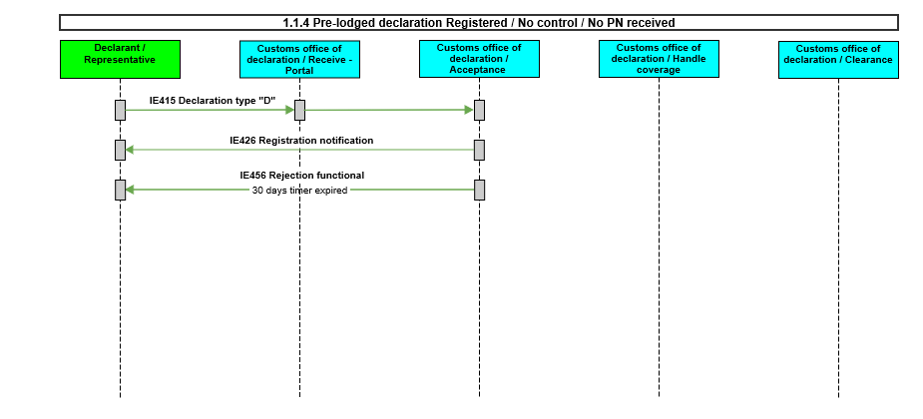

Acceptance of the IE415 Declaration type “D” and registration of the pre-lodged declaration with the IE426 Registration notification and an IE460 Control notification is sent.
No IE432 Presentation notification is received within the 30 days period.
Rejection of the IE415 Declaration type “D” with an IE456 Rejection functional message from the DECO system..
Note: the control notification is sent at this moment only in case the declarant has an AEOC authorisation.
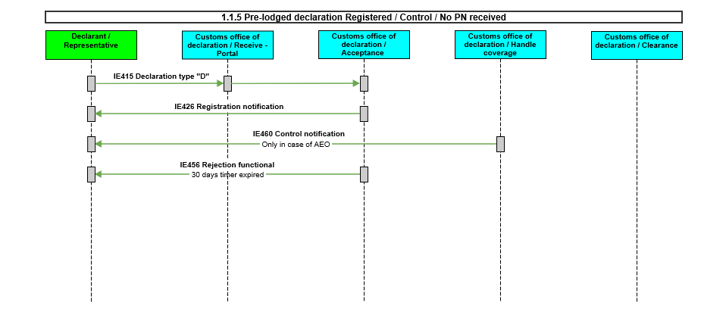

Processing of IE432 Presentation notification (PN)

The IE415 Declaration type “D” is registered and an IE426 Registration notification is sent.
Rejection of the IE432 Presentation notification in the “Portal” with a XMLCNT (XML Control Message) Rejection technical message or rejection of the IE432 Presentation notification with an IE456 Rejection functional message from the DECO system.
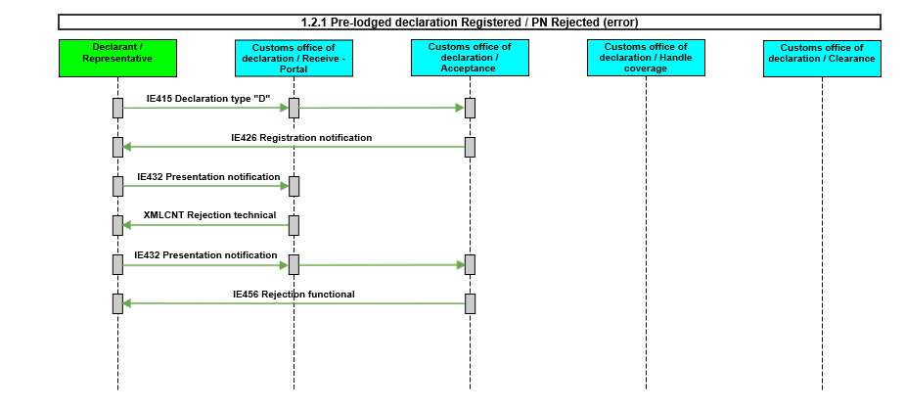

The IE415 Declaration type “D” is registered and an IE426 Registration notification is sent.
Rejection of the IE432 Presentation notification in the “Portal” with a XMLCNT XML control message (Rejection due to technical error(s)) or rejection of the IE432 Presentation notification with an IE456 Rejection functional message from the DECO system.
IE415 Declaration type “D” it is possible to send one or more IE432 Presentation notification messages.
In case there is no IE432 Presentation notification accepted after the 30 days period is expired the IE415 Declaration type “D” will be rejected with an IE456 Rejection functional message from the DECO system.
Note: In the 30 days period after the registration of the IE415 Declaration type “D” it is possible to send one or more IE432 Presentation notification messages.
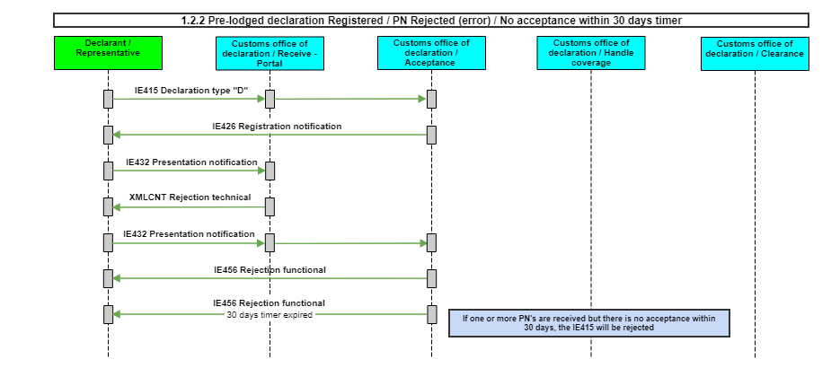

The IE415 Declaration type “D” is registered and an IE426 Registration notification is sent.
Acceptance of the IE432 Presentation notification.
The IE415 Declaration type “D” will be accepted and the IE428 Acceptance of Customs declaration is sent.
Note: The “additional declaration type” “D” is changed in “additional declaration type” “A”
In this scenario no Control notification is sent.
The goods will be released with an IE429 Release (CLE) and a NLTAX is sent.
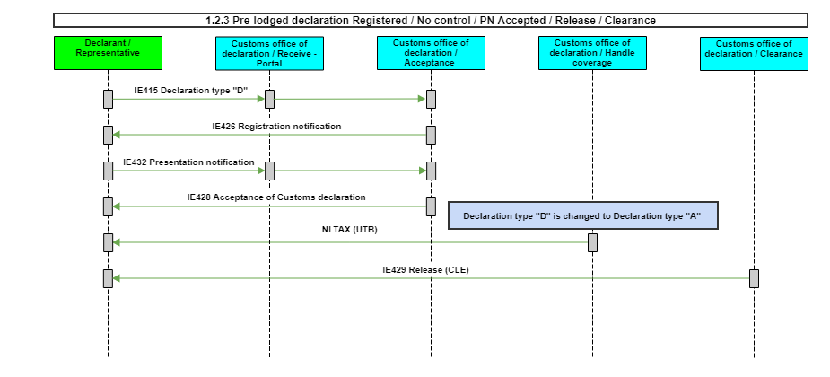

The IE415 Declaration type “D” is registered and an IE426 Registration notification is sent.
Acceptance of the IE432 Presentation Notification.
The IE415 Declaration type “D” will be accepted and the IE428 Acceptance of Customs declaration is sent.
In this scenario the IE460 Control notification is sent.
Note: The “additional declaration type” “D” is changed in “additional declaration type” “A”.
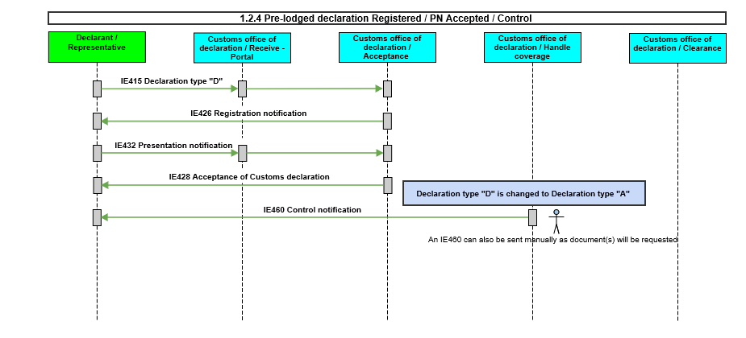

The IE415 Declaration type “D” is registered and an IE426 Registration notification is sent. Acceptance of the IE432 Presentation notification. The IE415 Declaration type “D” will be accepted and the IE428 Acceptance of Customs declaration is sent. The credit balance for the deferred payment (monthly credit) appears to be insufficient. The system does not release the goods until it has determined that the balance has been increased and is sufficient. DECO sends a notification that the balance is insufficient (NLCPI). After a configurable time period, DECO will send a reminder (NLCPR). If the credit is increased and determined that it is sufficient before the term expired, the goods will be released with an IE429 Release (CLE).
Note:
- The “additional declaration type” “D” is changed in “additional declaration type” “A”.
- This scenario is applicable for declarations with only additional procedure C07.
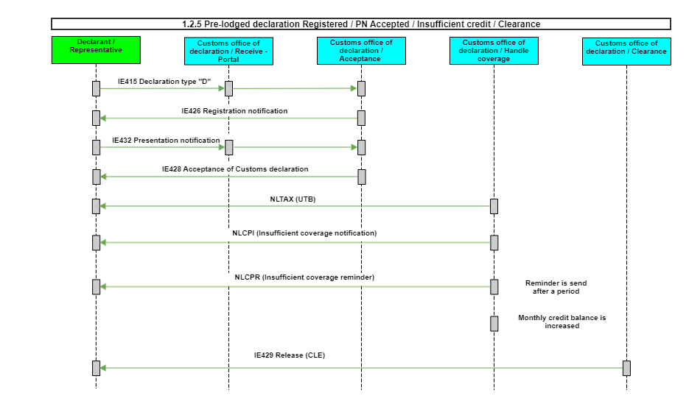

The IE415 Declaration type “D” is registered and an IE426 Registration notification is sent. Acceptance of the IE432 Presentation notification. The IE415 Declaration type “D” will be accepted and the IE428 Acceptance of Customs declaration is sent. The credit balance for the deferred payment (monthly credit) appears to be insufficient. The system does not release the goods until it has determined that the balance has been increased and is sufficient. DECO sends a notification that the balance is insufficient (NLCPI). After a configurable time period, DECO will send a reminder (NLCPR). If, after receiving one or more reminders, the declarant does not increase the monthly credit balance, DECO will not release the goods. In this case, the declarant receives an IE451. The declaration has thus reached a final status in the declaration processing process.
Note:
- The “additional declaration type” “D” is changed in “additional declaration type” “A”.
- This scenario is applicable for declarations with only additional procedure C07.

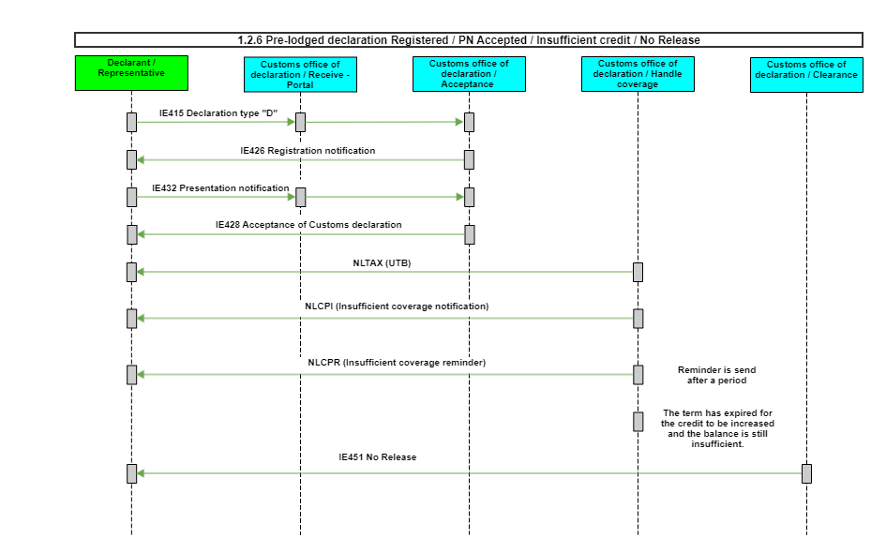

Handling after control

The IE415 Declaration type “D” is registered and an IE426 Registration notification is sent.
An IE460 Control notification (only in case of AEO) is sent.
Acceptance of the IE432 Presentation notification.
The IE415 Declaration type “D” will be accepted and the IE428 Acceptance of Customs declaration is sent.
Note: The “additional declaration type” “D” is changed in “additional declaration type” “A”.
Customs has decided that the goods cannot be released.
An IE451 No release is sent.
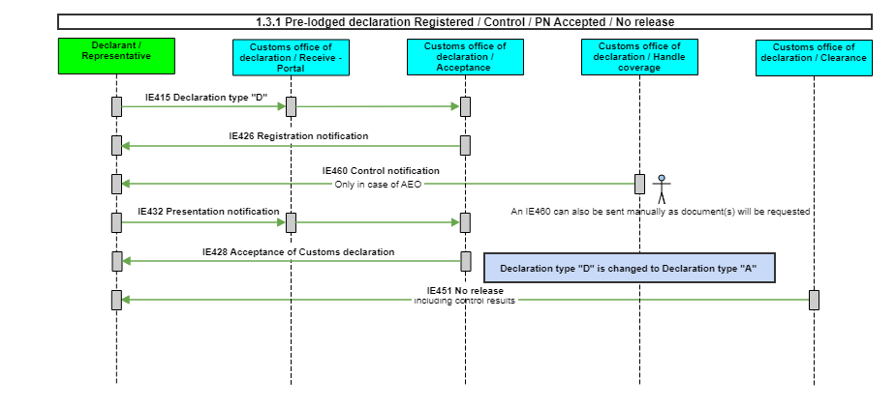

The IE415 Declaration type “D” is registered and an IE426 Registration notification is sent.
Acceptance of the IE432 Presentation notification.
The IE415 Declaration type “D” will be accepted and the IE428 Acceptance of Customs declaration is sent.
Note: The “additional declaration type” “D” is changed in “additional declaration type” “A”.
An IE460 Control notification is sent.
Customs has decided that the goods cannot be released.
An IE451 No release is sent.
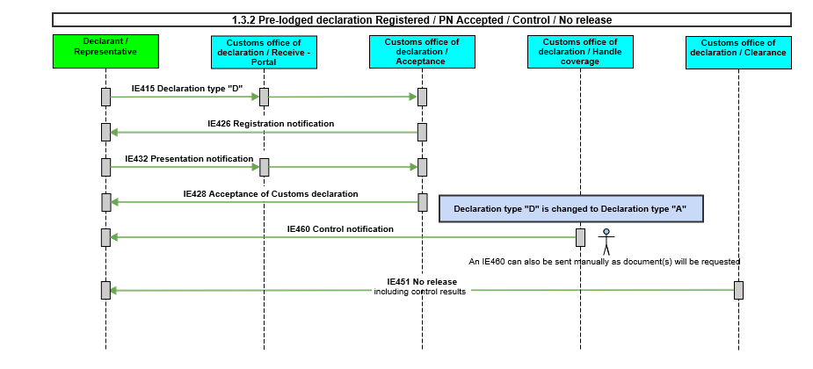

The IE415 Declaration type “D” is registered and an IE426 Registration notification is sent.
An IE460 Control notification (only in case of AEO) is sent.
Acceptance of the IE432 Presentation notification.
The IE415 Declaration type “D” will be accepted and the IE428 Acceptance of Customs declaration is sent.
Note: The “additional declaration type” “D” is changed in “additional declaration type” “A”.
Customs has decided that the goods can be released.
The goods will be released with an IE429 Release (CLE) and a NLTAX is sent.
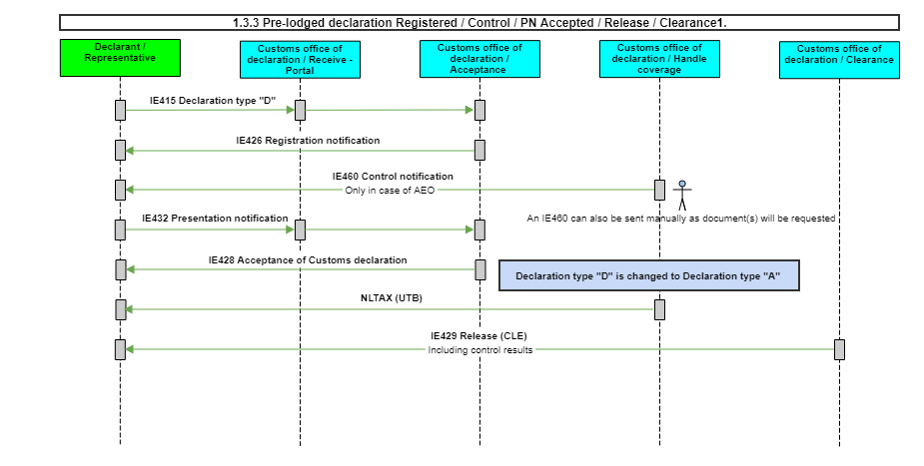

The IE415 Declaration type “D” is registered and an IE426 Registration notification is sent.
An IE460 Control notification (only in case of AEO) is sent.
Acceptance of the IE432 Presentation notification.
The IE415 Declaration type “D” will be accepted and the IE428 Acceptance of Customs declaration is sent.
Note: The “additional declaration type” “D” is changed in “additional declaration type” “A”.
Customs has decided that the goods can be released but they need more time to finish the control (for example in case of samples).
The goods will be released with an IE429 Release (ROG) and a provisional NLTAX is sent.
After control a new IE429 Release (CLE) and a final NLTAX is sent.
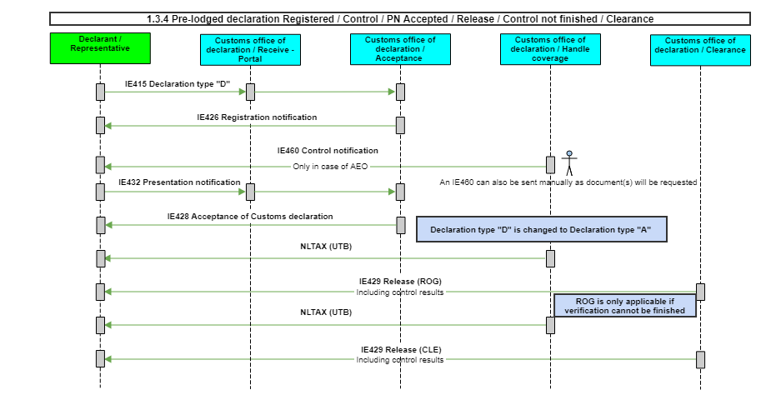

The IE415 Declaration type “D” is registered and an IE426 Registration notification is sent.
Acceptance of the IE432 Presentation notification.
The IE415 Declaration type “D” will be accepted and the IE428 Acceptance of Customs declaration is sent.
Note: The “additional declaration type” “D” is changed in “additional declaration type” “A”.
An IE460 Control notification is sent.
Customs has decided that the goods can be released.
The goods will be released with an IE429 Release (CLE) and a NLTAX is sent.
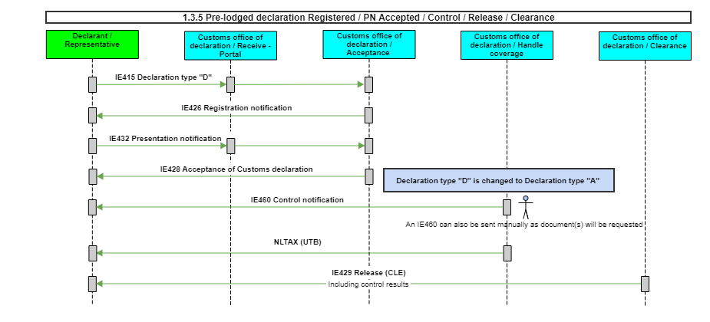

The IE415 Declaration type “D” is registered and an IE426 Registration notification is sent.
Acceptance of the IE432 Presentation notification.
The IE415 Declaration type “D” will be accepted and the IE428 Acceptance of Customs declaration is sent.
Note: The “additional declaration type” “D” is changed in “additional declaration type” “A”.
An IE460 Control notification is sent.
Customs has decided that the goods can be released but they need more time to finish the control (for example in case of samples).
The goods will be released with an IE429 Release (ROG) and a provisional NLTAX is sent.
After control a new IE429 Release (CLE) and a final NLTAX is sent.
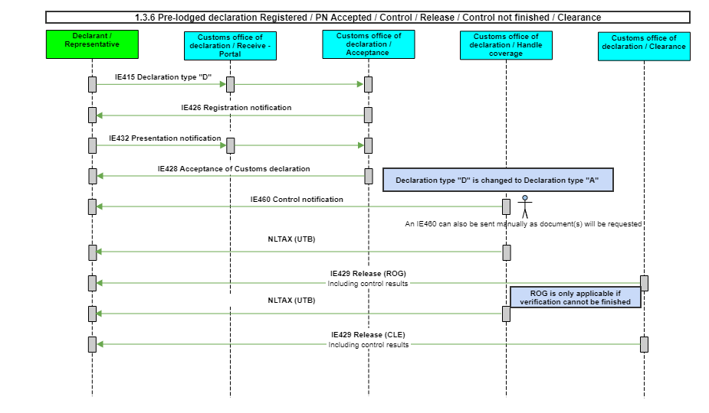

The IE415 Declaration type “D” is registered and an IE426 Registration notification is sent.
Acceptance of the IE432 Presentation notification.
The IE415 Declaration type “D” will be accepted and the IE428 Acceptance of Customs declaration is sent.
Note:
- The “additional declaration type” “D” is changed in “additional declaration type” “A”.
- This scenario is applicable for declarations with only additional procedure C07.
An IE460 Control notification is sent. Customs has decided that the goods can be released. The goods will be released with an IE429 Release (CLE) and in the case VAT is collected by Customs a NLTAX is sent.
In case the credit balance for the deferred payment (monthly credit) appears to be insufficient. The system does not release the goods until it has determined that the balance has been increased and is sufficient.
DECO sends a notification that the balance is insufficient (NLCPI). After a configurable time period, DECO will send a reminder (NLCPR).
If the credit is increased and determined that it is sufficient before the term expires, the goods will be released with an IE429 Release (CLE).
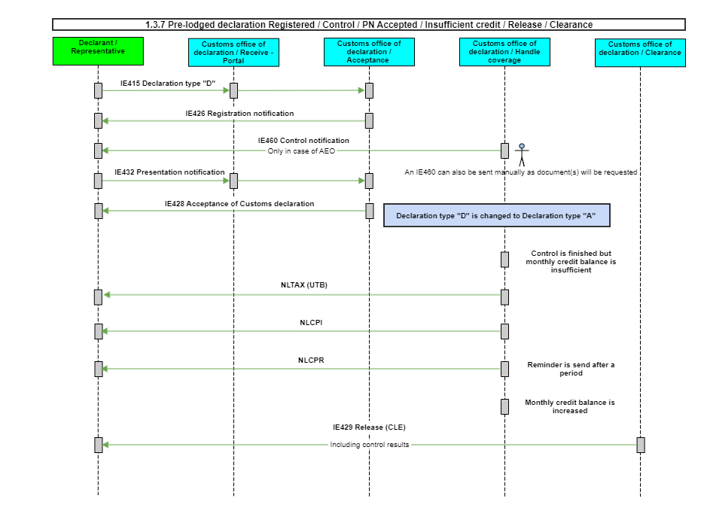

The IE415 Declaration type “D” is registered and an IE426 Registration notification is sent.
Acceptance of the IE432 Presentation notification.
The IE415 Declaration type “D” will be accepted and the IE428 Acceptance of Customs declaration is sent.
Note:
- The “additional declaration type” “D” is changed in “additional declaration type” “A”.
- This scenario is applicable for declarations with only additional procedure C07.
An IE460 Control notification is sent. Customs has decided that the goods can be released. The goods will be released with an IE429 Release (ROG) and in the case VAT is collected by Customs a provisional NLTAX is sent. After control a new IE429 Release (CLE) and in the case VAT is collected by Customs a final NLTAX is sent.
In case the credit balance for the deferred payment (monthly credit) appears to be insufficient. The system does not release the goods until it has determined that the balance has been increased and is sufficient.
DECO sends a notification that the balance is insufficient (NLCPI). After a configurable time period, DECO will send a reminder (NLCPR).
If the credit is increased and determined that it is sufficient before the term expires, the goods will be released with an IE429 Release (ROG).
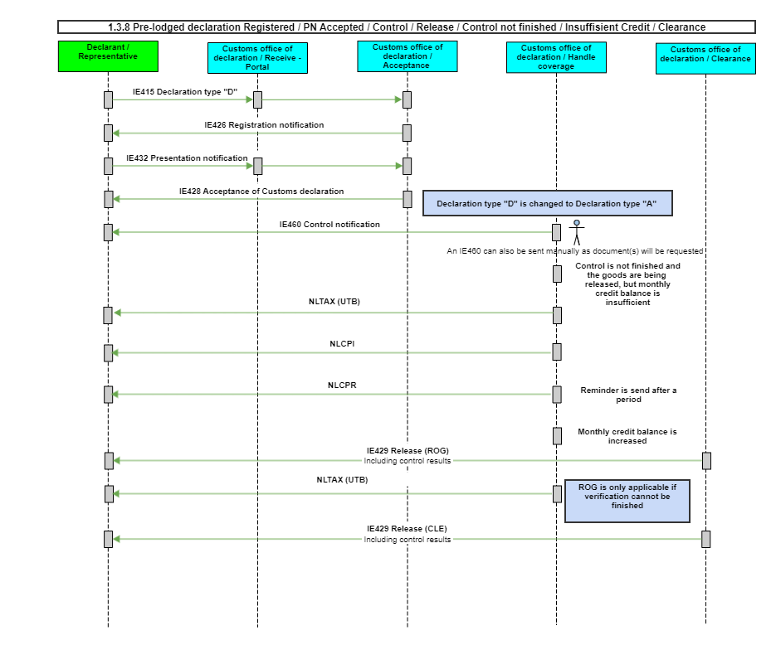

The IE415 Declaration type “D” is registered and an IE426 Registration notification is sent.
Acceptance of the IE432 Presentation notification.
The IE415 Declaration type “D” will be accepted and the IE428 Acceptance of Customs declaration is sent.
Note:
- The “additional declaration type” “D” is changed in “additional declaration type” “A”.
- This scenario is applicable for declarations with only additional procedure C07.
An IE460 Control notification is sent. Customs has decided that the goods can be released. The goods will be released with an IE429 Release (ROG) and in the case VAT is collected by Customs a provisional NLTAX is sent. After control a new IE429 Release (CLE) and in the case VAT is collected by Customs a final NLTAX is sent.
When the goods get released DECO will reserve the credits needed to release the goods. After the control the required amount can be higher than the reserved amount. In that case DECO will reserved the extra amount needed to give the final release.
In case the credit balance for the deferred payment (monthly credit) appears to be insufficient for the extra amount. The system does not give the final release until it has determined that the balance has been increased and is sufficient.
DECO sends a notification that the balance is insufficient (NLCPI). After a configurable time period, DECO will send a reminder (NLCPR).
If the credit is increased and determined that it is sufficient before the term expires, the goods will be released with an IE429 Release (CLE).
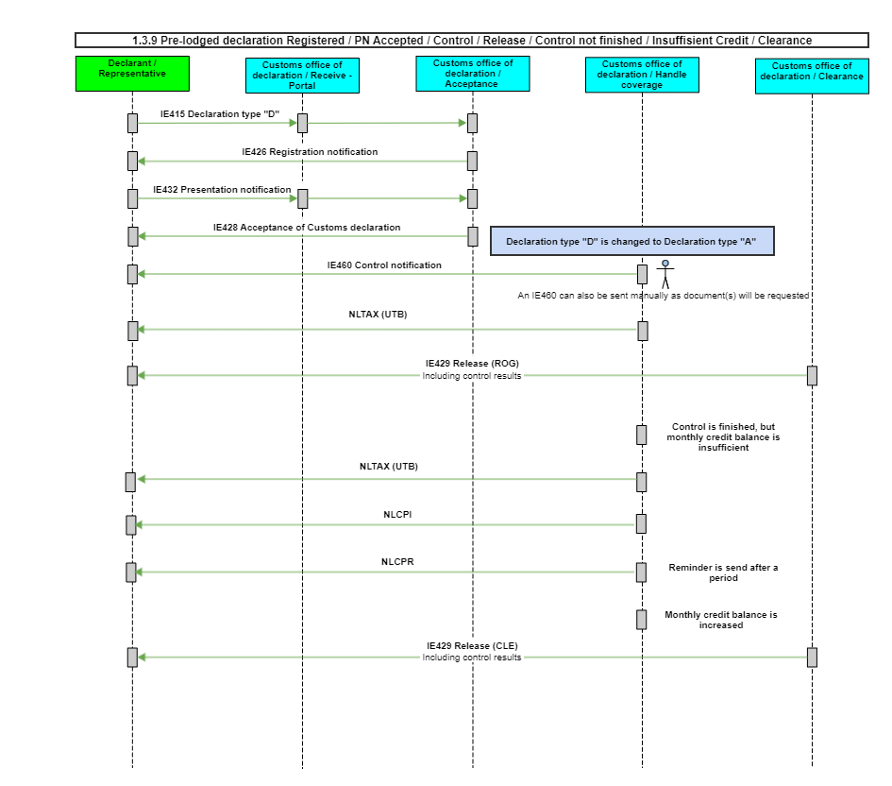

The IE415 Declaration type “D” is registered and an IE426 Registration notification is sent.
Acceptance of the IE432 Presentation notification.
The IE415 Declaration type “D” will be accepted and the IE428 Acceptance of Customs declaration is sent.
Note:
- The “additional declaration type” “D” is changed in “additional declaration type” “A”.
- This scenario is applicable for declarations with only additional procedure C07.
An IE460 Control notification is sent. Customs has decided that the goods can be released. The goods will be released with an IE429 Release (CLE) and in the case VAT is collected by Customs a NLTAX is sent.
In case the credit balance for the deferred payment (monthly credit) appears to be insufficient. The system does not release the goods until it has determined that the balance has been increased and is sufficient.
DECO sends a notification that the balance is insufficient (NLCPI). After a configurable time period, DECO will send a reminder (NLCPR).
If, after receiving one or more reminders, the declarant does not increase the monthly credit balance, DECO will not release the goods.
In this case, the declarant receives an IE451(No Release). The declaration has thus reached a final status in the declaration processing process.
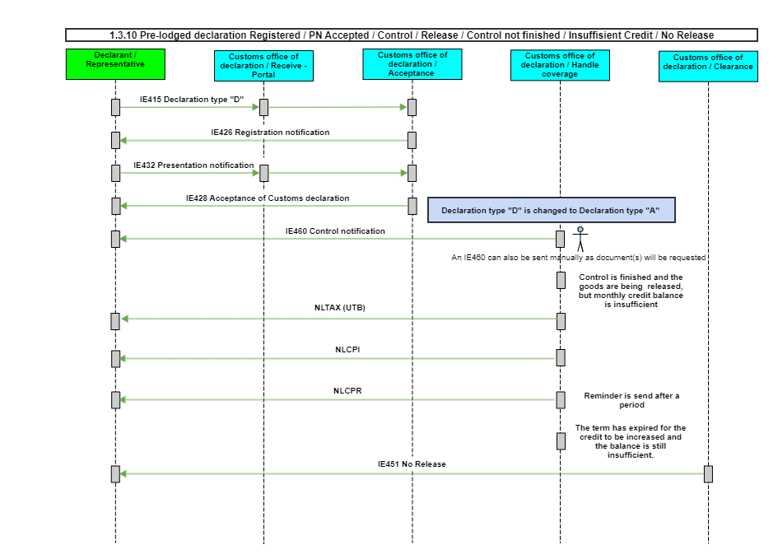

Processing of IE414 Invalidation request

Rejection of the IE415 Declaration type “D” in the “Portal” with a XMLCNT XML control message (Rejection due to technical error(s))or rejection of the IE415 Declaration type “D” with an IE456 Rejection functional message from the DECO system.
IE414 Invalidation request is sent before registration of the IE415 Declaration type “D”.
The IE414 Invalidation request will be rejected with IE456 Rejection functional message from the DECO system.
Note: It is possible that customs invalidates the declaration on legal grounds by sending an IE410 without having received a request for invalidation.
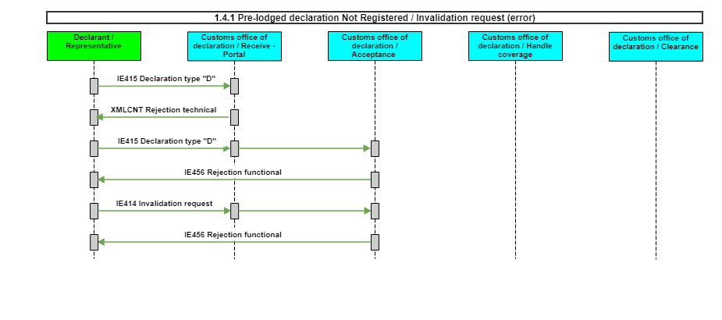

The IE415 Declaration type “D” is registered and an IE426 Registration notification is sent.
Rejection of the IE414 Invalidation request in the “Portal” with a XMLCNT XML control message (Rejection due to technical error(s)) or rejection of the IE414 Invalidation request with an IE456 Rejection functional message from the DECO system.
Note: It is possible that customs invalidates the declaration on legal grounds by sending an IE410 without having received a request for invalidation.
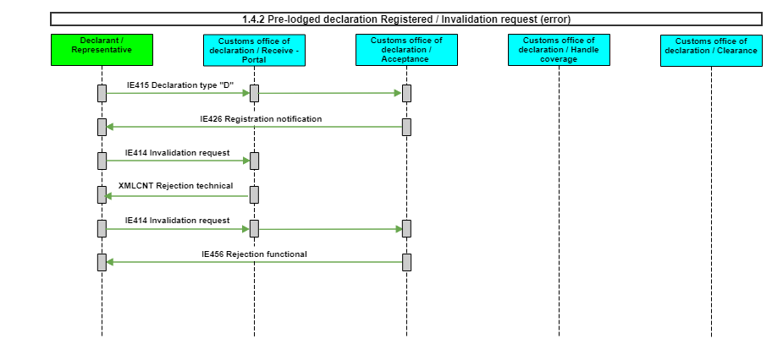

The IE415 Declaration type “D” is registered and an IE426 Registration notification is sent.
The IE414 Invalidation request is sent.
The DECO system will generate a positive decision and is sent with an IE410 Invalidation of Customs declaration (accepted).
Note: It is possible that customs invalidates the declaration on legal grounds by sending an IE410 without having received a request for invalidation.
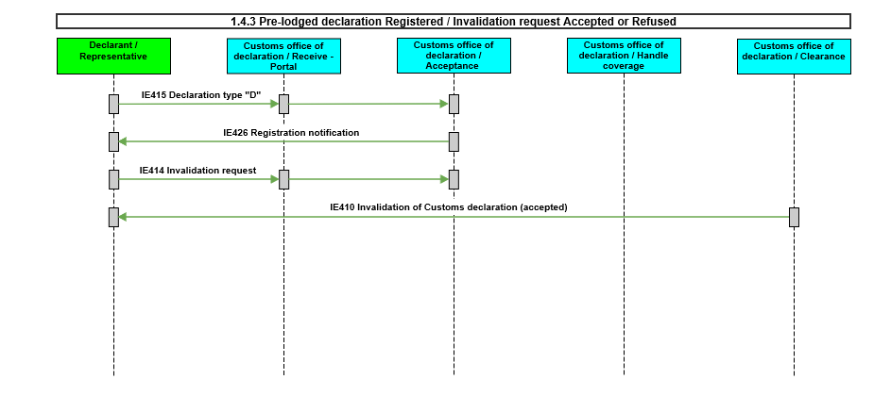

The IE415 Declaration type “D” is registered and an IE426 Registration notification is sent.
Acceptance of the IE432 Presentation notification.
The IE415 Declaration type “D” will be accepted and the IE428 Acceptance of Customs declaration is sent.
Note: The “additional declaration type” “D” is changed in “additional declaration type” “A”.
Rejection of the IE414 Invalidation request in the “Portal” with a XMLCNT XML control message (Rejection due to technical error(s)) or rejection of the IE414 Invalidation request with an IE456 Rejection functional message from the DECO system.
Note: It is possible that customs invalidates the declaration on legal grounds by sending an IE410 without having received a request for invalidation.
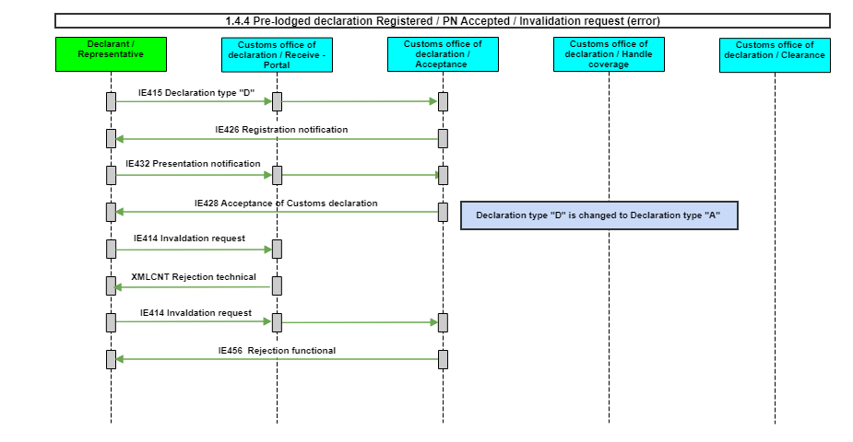

The IE415 Declaration type “D” is registered and an IE426 Registration notification is sent.
Acceptance of the IE432 Presentation notification.
The IE415 Declaration type “D” will be accepted and the IE428 Acceptance of Customs declaration is sent.
Note: The “additional declaration type” “D” is changed in “additional declaration type” “A”.
The IE414 Invalidation request is sent.
Customs decides to accept the Invalidation request with an IE410 Invalidation of Customs declaration (accepted) or to refuse the invalidation request with an IE456 Rejection functional message.
Note: It is possible that customs invalidates the declaration on legal grounds by sending an IE410 without having received a request for invalidation.
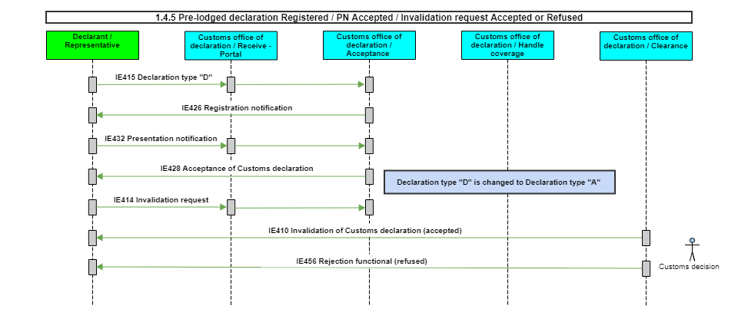

The IE415 Declaration type “D” is registered and an IE426 Registration notification is sent.
Acceptance of the IE432 Presentation notification.
The IE415 Declaration type “D” will be accepted and the IE428 Acceptance of Customs declaration is sent.
Note: The “additional declaration type” “D” is changed in “additional declaration type” “A”.
The goods have been released with an IE429 Release (CLE) and a NLTAX has been sent.
Rejection of the IE414 Invalidation request, which may be sent within 90 days after the IE415 will be accepted, in the “Portal” with a XMLCNT XML control message (Rejection due to technical error(s)) or rejection of the IE414 Invalidation request with an IE456 Rejection functional message from the DECO system.
Note: It is possible that customs invalidates the declaration on legal grounds by sending an IE410 without having received a request for invalidation.
Note: A request for invalidation (IE414) received 90 days after the IE415 is accepted will be rejected with an IE456.
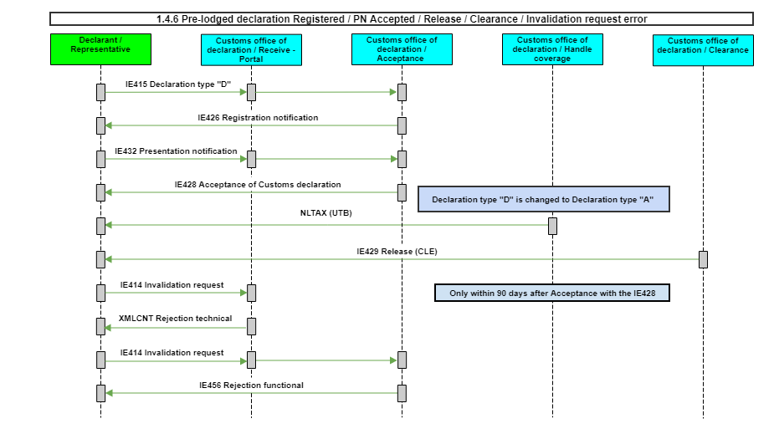

The IE415 Declaration type “D” is registered and an IE426 Registration notification is sent.
Acceptance of the IE432 Presentation notification.
The IE415 Declaration type “D” will be accepted and the IE428 Acceptance of Customs declaration is sent.
Note: The “additional declaration type” “D” is changed in “additional declaration type” “A”.
The goods have been released with an IE429 Release (CLE) and a NLTAX has been sent.
The IE414 Invalidation request is sent within 90 days after the IE415 will be accepted.
Customs decides to accept the Invalidation request with an IE410 Invalidation of Customs declaration (accepted) or to refuse the invalidation request with an IE456 Rejection functional message.
Note: It is possible that customs invalidates the declaration on legal grounds by sending an IE410 without having received a request for invalidation.
Note: A request for invalidation (IE414) received 90 days after the IE415 is accepted will be rejected with an IE456.
